**Name**

**Lab # 9:**

**Exercise one:**

**Sandbox Installed**

**Sandbox Activated**

**Sandboxed browser**

**Browser Slowed down**

**Running notepad**

**Sandboxed notepad**

**Q1:**

Sandbox is actually a lightweight virtual machine. It is often used by developers and researchers for testing a new software within controlled environments. It creates virtual hard drive, computer storage and memory. Sandboxie is slower because of its popularity and number of projects running on single server.

**Exercise 2:**

Q2:

We have explored how events are generated in windows and which type of event occurs.

First we open administrative tools

It shows event types and their typing plus their logs .

Application and services it contains default generated logs as shown.

It shows warning event types of warning events that occur on a certain time.

It shows error events

It shows audit success events and their time

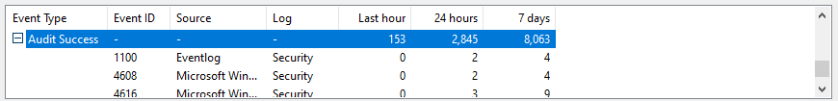

This shows information events about application logs.

Here we show windows generated default logs. We have expanded security events that occur as shown 27,153 events occured

**Q3 part b of exercise3**

Exercise 3:

In this we will demonstrate how to create custom views

We have done settings to show our event such as logged at any time means system will capture event every time we log in. also event level and other settings now we click ok and our event gets created.

We can view our events file name as All events created here it shows 12,739 events created.

After that we restart our system to see if there are new events available. As you can see below 50 new events are available.

As you can see first is error event and second is information event and so on.

